**Technical Documentation – PENC MiddleWare – BIP Service Control**

1. Workflow – Stops, Starts, Restarts BIP Weblogic Services services

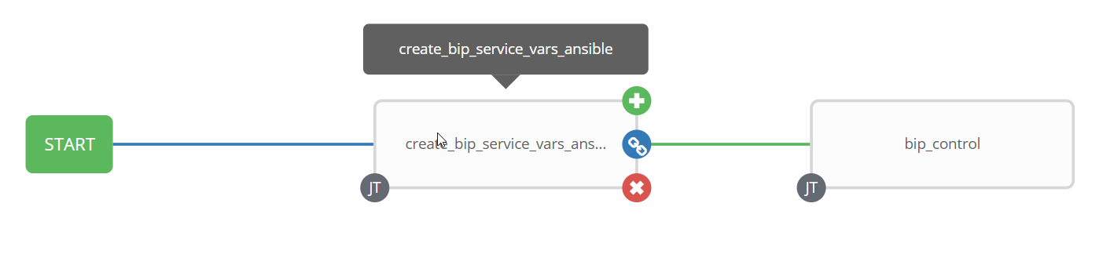

1. Survey – User Supplied Variables

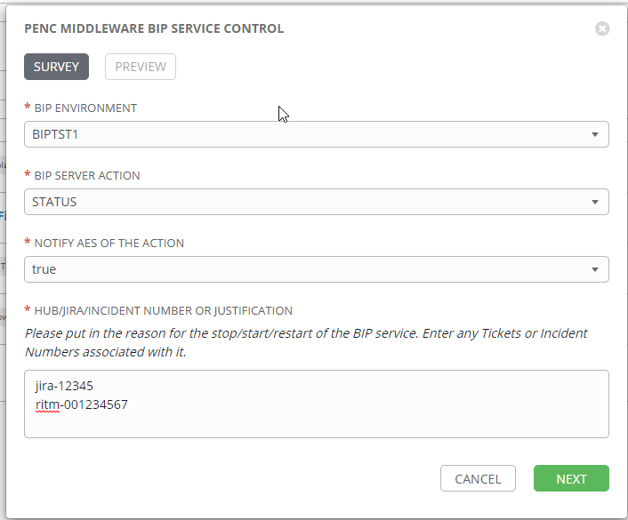

| **Survey Extra Variables** | **Prompt** | **Type** | **Description and Usage** |
| --- | --- | --- | --- |
| bip_env | BIP Environment | Multiple Choice Single Pick | This is a drop down list of the current BIP Environments  BIPDEV3  BIPDEVL  BIPRDEV  BIPTST1  BIPTST2  BIPTST3  BIPTRNG  BIPMUAT  BIPPROD |
| bip_command | BIP Server Action | Multiple Choice Single Pick | The available commands for the BIP Environment  Drop Down List:  RESTART  START  STATUS  STOP |
| notify_aes | Notif AES Of The Action | Multiple Choice Single Pick | If set to true send an email to the email addresses defined in {{aes_mail_list}}. |
| aes_note | HUB/JIRA/INCIDENT Number or Justification | Text Area (20000 characters) | Any information entered here will be included in the emails generated. |

1. Jobs Used by the workflow - http://owl.penc.local:18080/svn/deploy_automation/trunk/Ansible_PlayBooks/Utilities

| **Job Template** | **Ansible Playbook** | **Credentials / host** | **Project** | **Description and Usage** |
| --- | --- | --- | --- | --- |
| create_bip_service_vars_ansible | create_bip_service_vars_ansible.yml | None – runs on localhost as awx linux user | Utilities | Creates Variables/Artifacts for use within the workflows, based on the User supplied survey results.  Artifacts Defined with examples  bip_host: talaus1bcp  bip_port: 9704  bip_protocol: http  date_time: '20210106_1436' |
| tomcat_service_control | tomcat_service_control.yml | oracle for {{bip_host}} | Utilities | On {{bip_host}}:  With {{bip_command}} == ‘STOP’ or ‘RESTART’   * retrieves the process id for the Weblogc BIP Admin Server service to be stopped into {{bip_weblogic_pid}} variable. * executes ‘cd /pencmw/oracle/nodemanager;/pencmw/oracle/nodemanager/domain_stop.sh;sleep 20 * waits for the /proc/{{bip_weblogic_pid.stdout}}/status to longer exist (i.e. BIP Weblogic Adminserver process no longer exists)   With {{bip_command}} == ‘START’ or ‘RESTART’   * Execute ‘cd /pencmw/oracle/nodemanager;/pencmw/oracle/nodemanager/domain_start.sh’ * Waits for the {{bip_port}} to be available   With {{bip_command}} == ‘STATUS’ or ‘STOP’ or ‘START’ or ‘RESTART’   * Checks the url http://{{bip_host}}.penc.local:{{bip_port}}/xmlpserver * Sends an email to the Ansible Tower user who initiated the workflow with the results * If {{notify_aes}} is set to true send an email to the addresses defined in {{aes_mail_list}} with the results |

1. Workflow Extra Vars – Defined at the Workflow Level

|  |  |  |
| --- | --- | --- |
| **Extra Variable** | **Example Values** | **Description and Usage** |
| aes_mail_list | ---  aes_mail_list:  - Mike.Charchuk@dxcas.com | If this variable is defined to anything other than ‘’ and {{notify_aes}} == true an email with the actions taken to addresses defined in {{aes_mail_list}}.  Note: the following are valid aes_mail_list entries:  aes_mail_list: ‘’  aes_mail_list:   * [Mike.Charchuk@pensionsbc.ca](mailto:Mike.Charchuk@pensionsbc.ca) * [Mike.Charchuk@dxcas.com](mailto:Mike.Charchuk@dxcas.com)   aes_mail_list:   * [Mike.Charchuk@pensionsbc.ca](mailto:Mike.Charchuk@pensionsbc.ca) |